Name___________________________________

Quick Quiz

**Unit Rate 14**

Identify the unit rate:

1. scored 228 points in 12 games 2. $y=7x$

**_________ points per game unit rate =_________**

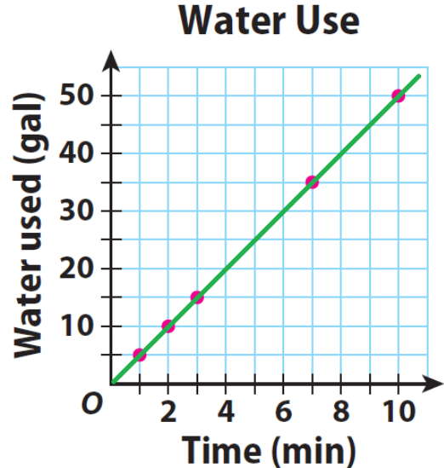

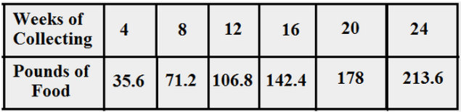3. 4.

**________**

**gallons per**

**_________ pounds collected per week minute**

____________________________________________________________________________

Corrections

**Unit Rate 14**

Identify the unit rate:

1. scored 228 points in 12 games 2.

**_________ points per game unit rate =_________**



****3. 4.

**________**

**gallons per**

**_________ pounds collected per week minute**